**LAB EXERCISE 1 (2.5%)**

**Question 1 ( page 80 -Lab Book)**

Trace the following program and show the output. Draw a memory layout for the program.

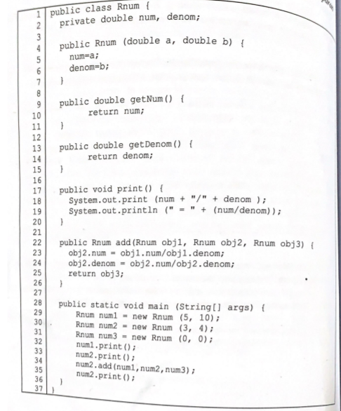

**Question 2**

Given the following UML diagram in Figure 1, write two complete Java programs, **Book.java** and **TestBook.java** based on the instruction given in (a) and (b).

|  |
| --- |
| **Book** |
| **- bookInstance : int**  **- title : String**  **- author : String**  **- price: double**  **- yearPublish : int**  **- discount : double** |
| **+ Book(String, String)**  **+ void readInput()**  **+ double calcBookPrice()**  **+ String toString()**  **+ suitable accessor methods** |

|  |
| --- |
| **TestBook** |
|  |
| **+ static void main(String args[])** |

**Figure 1:** UML diagram

a) Write a class **Book** with the following methods: (37 Marks)

(i) Write constructor for class **Book** that initializes **title** and **author** instance variables through parameter passing. The constructor must be able to track the number of instances for class **Book** using **static** **bookInstance** variable.

[4 Marks]

(ii) Write suitable code for the getter (accessor) methods. [3 Marks]

(iii) Write method **readInput()** which read inputs for **yearPublish** and **price** from keyboard. Use **Scanner** class for this purpose. [7 Marks]

(iv) Write method **calcBookPrice()** which able to return the value of the book price after discount. Discount is given based on the **yearPublish**. If **yearPublish** is less than year 2005, discount 50% will be given. If **yearPublish** is from 2005 until 2014, discount 25% will be given. If the book **yearPublish** is 2015 no discount will be given. [10 Marks]

(v) Write method **toString()** which creates a string of book information and the price after discount given. [7 Marks]

b) Write a class **TestBook** that only has **main()** method with the following codes:

(18 Marks)

(i) Create three (3) objects **book1**, **book2** and **book3** using the constructor.

[6 Marks]

(ii) Use method **readInput()** to read input from keyboard for each objects.

[3 Marks]

(iii) Display all the values for each object using the method **toString()**.

[3 Marks]

(iv) Display the price of the book after discount using the method **calcBookPrice()**. [3 Marks]

(v) Display the number of instance of class **Book** using **static** instance variables **bookInstance.** [1 Mark]

The program should produce the output as shown in Figure 2. Note that the text in bold indicates input entered by the user.

Enter the year publish of your book: **2004**

Enter the price of your book: RM**65**

Enter the year publish of your book: **2015**

Enter the price of your book: RM**54**

Enter the year publish of your book: **2008**

Enter the price of your book: RM**70**

Book Name : Java Programming

Author Name : Abu Bakar

Year Publish : 2004

Book Price : RM65.0

Book Price after Discount : RM32.5

Book Name : Programming Technique

Author Name : Rafeah Ahmad

Year Publish : 2015

Book Price : RM54.0

Book Price after Discount : RM54.0

Book Name : Happy Programming

Author Name : Sharif Hassan

Year Publish : 2008

Book Price : RM70.0

Book Price after Discount : RM52.5

The number of books purchased: 3

Press any key to continue . . .

**Figure 2:** Example output